May 9, 2019
To: All Agencies
From: Randy Vaughn, Director, APOSTC Law Enforcement Academy-Tuscaloosa
Re: UPDATED!! Housing Options for APOSTC Law Enforcement Academy-Tuscaloosa (LEAT)
In an continuing effort to provide the best housing option at an affordable price to agencies sending their officers to the LEAT, we would like to introduce our newest housing vendor, The Grand at Rum Creek Apartments. The cost per each officer is $1,400 for a 13-week academy. After successful completion of the Law Enforcement Academy each agency is eligible to apply for re-imbursement for housing of up to $1,300, meaning the agency will only be paying $100 for housing over the 13-week session.
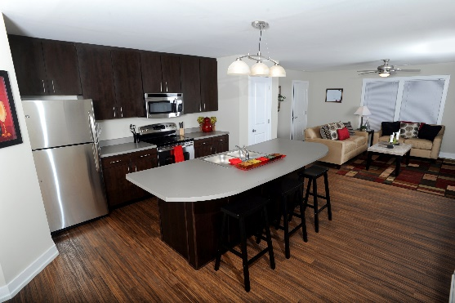
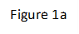
This housing covers a high end private, locked bedroom, private bath, located in a 4-bedroom, 1,700 square ft townhome. The Grand will provide all linens needed, a TV in common living room area, and a welcome kit (toothbrushes, coffee pods, etc.) to get the officers started. The townhome has a full-size kitchen, high end appliances, washer and dryer, cable and wireless high-speed internet, and balcony (figure 1a). The other bedrooms will be occupied by other students also attending LEAT. A sample diagram is shown (figure 1b). Each bedroom is furnished with a full-size bed, desk, and dresser.
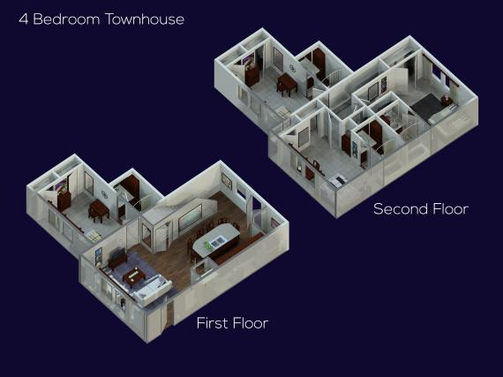
The Grand is a gated community, and they employ off-duty TPD officers for security. Officers staying at the Grand are allowed to use all the amenities, including the swimming pools, hot tubs, workout facilities, study rooms, tennis courts and club house. Officers will be issued a gate pass, key for the townhome and key for their individual bedrooms.
Figure 1b
If you wish to learn more about the amenities at the Grand, visit their website at www.thegrandatrumcreek.com. If you wish to reserve a room for an upcoming session of LEAT, please notify Capt. Vaughn at rvaughn@leat.org or call LEAT at 205-759-3000.
We will continue to offer the other housing options we have offered in the past and have the preferred housing providers listed below with pricing and amenities listed. Thank you again for your consideration of the Law Enforcement Academy-Tuscaloosa and please let me know if you have any questions.
Preferred Housing Vendors for
APOSTC Law Enforcement Academy-Tuscaloosa
March 21, 2019

Housing Provider | Cost per session | Notes
The Grand at Rum Creek | $1,400 | Cost is for full, continuous 13 weeks of stay. All necessities provided.
AL Canine Training Center | $1,300 | Bunk style rooms, 30 minutes from LEAT, shared bathrooms.
Home2 Suites/Hilton | $4,108 | Hotel room, only for four nights each week. Must check out each Thursday and check back in each Sunday.
LaQuinta Inn | $4,679 | Hotel room, only for four nights each week. Must check out each Thursday and check back in each Sunday.
Fairfield Inn by Marriott | $4,800* | Hotel room, only for four nights each week. Must check out each Thursday and check back in each Sunday.
Country Inn & Suites | $4,800* | Hotel room, only for four nights each week. Must check out each Thursday and check back in each Sunday.
Courtyard | $4,800* | Hotel room, only for four nights each week. Must check out each Thursday and check back in each Sunday.
*subject to verification
* Current rate is being confirmed

