September 23, 2019
To: All Agencies
From: Randy Vaughn, Director, APOSTC Law Enforcement Academy-Tuscaloosa
Re: Housing options for two-week Lateral/Refresher course
Our Basic Session preferred housing vendor, the Grand at Rum Creek Apartments, has graciously offered to extend special pricing for agencies needing to send their officer to LEAT for the two-week Lateral/Refresher couree. The cost per each officer is $400 total for the full two-week course. Officers will be allowed to check in the Sunday before the course begins and can checkout the weekend after completion of the course. LEAT’s Lateral Refresher course begins December 2, 2019.
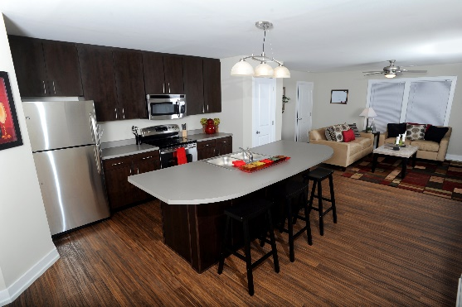
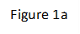
This housing covers a high end private, locked bedroom, private bath, located in a 4-bedroom, 1,700 square ft townhome. The Grand will provide all linens needed, a TV in common living room area, and a welcome kit (toothbrushes, coffee pods, etc.) to get the officers started. The townhome has a full-size kitchen, high end appliances, washer and dryer, cable and wireless high-speed internet, and balcony (figure 1a). The other bedrooms will be occupied by other students also attending LEAT. Each bedroom is furnished with a full-size bed, desk, and dresser. A picture of one of the unit’s main living area is shown in figure 1a and a sample diagram is shown in figure 1b.
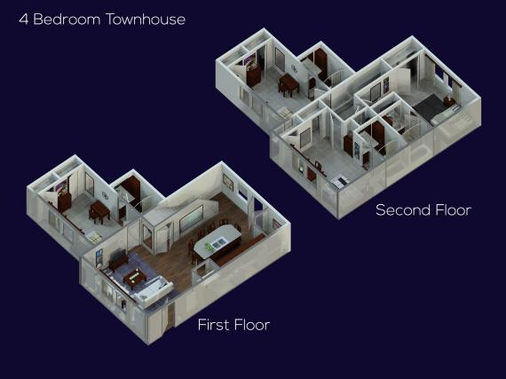
The Grand is a gated community, and they employ off-duty TPD officers for security. Officers staying at the Grand are allowed to use all the amenities, including the swimming pools, hot tubs, workout facilities, study rooms, tennis courts and club house. Officers will be issued a gate pass, key for the townhome and key for their individual bedrooms.
If you wish to learn more about the amenities at the Grand, visit their website at www.thegrandatrumcreek.com. If you wish to reserve a room for an upcoming session of LEAT, please notify Capt. Vaughn at rvaughn@leat.org or call LEAT at 205-759-3000.
Figure 1b

