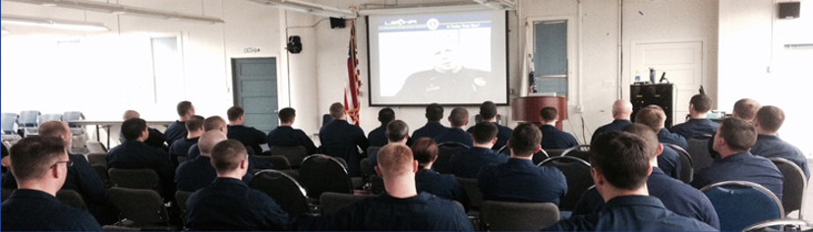
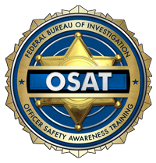
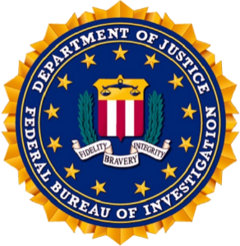
U. S. Department of Justice
Federal Bureau of Investigation
Officer Safety Awareness Training

A close look at why our nation’s law enforcement professionals are being assaulted and killed feloniously or accidentally, with a focus on prevention.
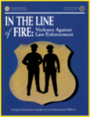
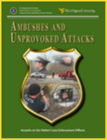
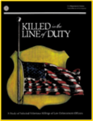

Officer and Offender Perceptions
Training
Foot Pursuits
Drawn Gun
Arrest Situations and Handcuffing
“Is Today Your Day?”
Ambushes and Unprovoked Attacks
Street Combat Veterans
Traffic Stops
Will to Win and Will to Survive
The Deadly Mix and Conclusion
Officer & Offender Perceptions
Training
Foot Pursuits
Drawn Gun
Arrest Situations & Handcuffing
“Is Today Your Day”
Ambushes and Unprovoked Attacks
Street Combat Veterans
Traffic Stops
Will to Win & Will to Survive
The Deadly Mix & Conclusion

“Providing law enforcement with perspective for a safer tomorrow.”
Date: Wednesday May 27th 2026 Time:8 am-5 pm
Location: Cherokee County Sheriff’s Office Training Center
1025 Bristow Gap Road Leesburg AL 35983

POC info: (name, email, phone, etc.)
To register contact:
Sgt. Mike Farrell
E-mail : mfarrell@cherokeecountyalsheriff.com
Phone : (205)928-1055

